50 Dangerous Things… Camp considers health and safety to be of utmost importance. We comply with The Health and Safety at Work Act 1974 and the Workplace (Health, Safety and Welfare) Regulations 1992 at all times. 50DT camp has appropriate insurance cover, including public liability insurance.

THIS POLICY IS IN ADDITION TO AND SHOULD BE READ IN CONJUNCTION WITH THE HEALTH AND SAFETY POLICY (2020) AND THE TERMS AND CONDITIONS OF BOOKING (2020).

50 Dangerous Things Camp will take place in very different circumstances during Summer 2020. As such, it has been necessary to change the way we manage the camp, and how we use the site, in order to make it possible to run at all. Please take the time to read this document, so that you understand how we plan to keep your children, and ourselves, as safe as possible with respect to Covid-19 Coronoavirus.

Please note: we continue to risk assess 50DT ACTIVITIES on the basis of “as safe as necessary”.

- The same members of staff will be on duty every day during the 3 days 50DT will operate each week in Summer 2021.

- Handwashing facilities will be provided in the Year 2 toilets, and hand sanitisers will be available at each Hub (Pond Area, Infant Field, Infant Playground) and around the grounds. Children will be instructed and supported to wash hands frequently and always after participating in activities or before eating or drinking.

- We will model and encourage good respiratory practice – catch it, bin it, kill it.

- Children will be encouraged to use the toilet facilities one at a time, and toilet facilities will be cleaned at least twice each day, prior to our snack and lunch times.

- Details of children attending and parents / carers dropping off and collecting children will be kept for 21 days after the final Summer 2021 session and shared with the government’s Test and Trace programme if requested.

This policy is subject to change and will be amended as necessary if Government guidelines change.

This policy was adopted by: 50 Dangerous Things… camp | 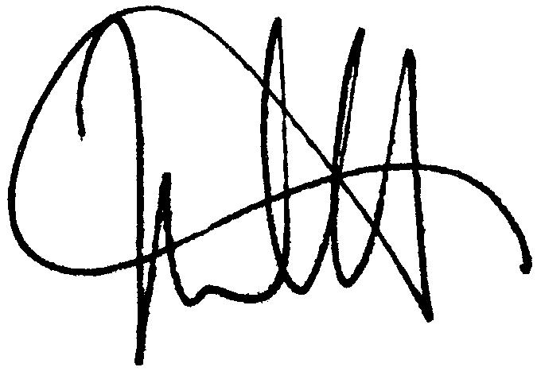  Date: 16th August 2021
To be reviewed: 1st July 2022 | Signed:

Written in accordance with the

DfE Protective measures for out-of-school settings during the coronavirus (COVID-19) outbreak, published 1 July 2020

DCMS Guidance for providers of outdoor facilities on the phased return of sport and recreation in England, updated 7 July 2020

